

SUMMER INTERNSHIP REPORT


INDIAN RAILWAY CATERING AND TOURISM
CORPORATION LIMITED

A Report on
Financial analysis of IRCTC Rail Neer Plants. Plants

(April 7th, 2025 to June 7th, 2025)

Submitted by-
Ankit Akshay Tirkey(MBA24009)

CERTIFICATE

This is to certify that Ankit Akshay Tirkey , Tanya Pawar , Roshini Sahu students of Master of Business Administration (MBA) at the Indian Institute of Management, Sirmaur, has successfully completed his Summer Internship Training in the Finance Department of Indian Railway Catering and Tourism Corporation Limited (IRCTC). The internship was conducted under the guidance of Mr. S. Subin Shah (Chief Supervisor) Digital Marketing, IRCTC Corporate Office, New Delhi, from 7th April 2025 to 7st June 2025.

(AGM/HRD) (CHIEFSUPERVISOR/DIGITAL MARKETING)

ACKNOWLEDGEMENT
I would like to express my sincere gratitude to the Indian Railway Catering and Tourism Corporation Limited (IRCTC) for providing me with the opportunity to undertake my Summer Internship in the Digital Marketing domain. The experience has been immensely enriching and has contributed significantly to my professional and personal growth.
I am deeply thankful to Mr. S. Subin Shah(Chief Supervisor) Digital Marketing, IRCTC Corporate Office, for his valuable guidance, encouragement, and support throughout the internship period. His mentorship in digital campaign planning, performance tracking, and online engagement strategies has greatly enhanced my understanding of digital marketing operations within a public sector enterprise.
I would also like to extend my heartfelt thanks to the entire Digital Marketing team for their cooperation and assistance during the course of the internship.
Finally, I express my gratitude to the Indian Institute of Management, Sirmaur, for facilitating this internship as part of my Master of Business Administration (MBA).

CERTIFICATE

This is to certify that Mr Ankit Akshay Tirkey, a student of Master of Business Administration (MBA) at the Indian Institute of Management, Sirmaur, has successfully completed his Summer Internship Training in the Finance Department of Indian Railway Catering and Tourism Corporation Limited (IRCTC). The internship was conducted under the guidance of Mr. Sanjiv Kumar , JGM (Finance), IRCTC Corporate Office, New Delhi, from 7th April 2025 to 7st June 2025.

(AGM/HRD) (JGM/FINANCE)

EXECUTIVE SUMMARY

This report presents an in-depth financial analysis of IRCTC’s Rail Neer packaged drinking water operations, focusing on evaluating the feasibility of setting up a new plant under the Public-Private Partnership (PPP) model. Drawing from extensive data of existing plants, the project includes projected financial statements, business model comparisons, cost structure evaluation, and performance metrics. It highlights the production capacity, revenue contribution, operational challenges, and profitability patterns across different plant models—Company Owned, PPP with Capital Support (PPP-CS), and PPP without Capital Support (PPP-WCS). The study identifies performance gaps, assesses long-term financial sustainability, and recommends the most efficient project structuring model for future expansion. It concludes that with appropriate pricing, operational optimization, and model selection, the Rail Neer business can be scaled sustainably, contributing significantly to IRCTC’s broader service ecosystem.

INTRODUCTION

The Indian Railway Catering and Tourism Corporation Limited (IRCTC), a Mini-Ratna public sector undertaking under the Ministry of Railways, plays a vital role in enhancing travel experiences across India. Among its many services—ranging from internet ticketing to luxury tourism—Rail Neer, its packaged drinking water brand, ensures clean and safe hydration for millions of railway passengers.
As of FY 2023–24, IRCTC operates 19 Rail Neer plants spread across the country, categorized into three operational models: Company Owned, PPP with Capital Support (PPP-CS), and PPP without Capital Support (PPP-WCS). These plants collectively produced nearly 395 million bottles, with an overall utilization rate of 73.73%, highlighting significant scope for capacity optimization.
This project was undertaken to assess the financial feasibility of setting up a new Rail Neer plant, using performance data from existing plants as benchmarks. It also investigates the most suitable business model for implementation, considering factors such as capital investment, operational efficiency, regulatory compliance, and long-term profitability. In alignment with Railway Board directives, the analysis emphasizes the PPP route as the preferred strategy, with particular focus on capital-supported partnerships to ensure financial viability and risk mitigation.

Introduction of the organisation

Indian Railway Catering and Tourism Corporation (IRCTC) is a premier public sector enterprise under the Ministry of Railways, Government of India. With 25 years of trusted service, IRCTC offers a seamless and comprehensive travel experience to passengers across India. From online railway ticketing and onboard catering to packaged drinking water and tourism, it serves as a one-stop solution for millions of travelers. IRCTC plays a pivotal role in shaping the future of travel through innovation, digitalization, and quality services.

Services Provided by IRCTC
Internet Ticketing
- 82.68% of reserved ticket bookings in Indian Railways
- 12.38 lakh tickets booked daily (FY 2023–24)
- Over 28,000 tickets booked per minute using NGeT
- 12.21 crore downloads of the IRCTC app
Catering Services
- Onboard catering in 1,250+ trains
- e-Catering at 400+ stations with 2,000+ partners
- Regional menus in all 51 Vande Bharat trains
- Serves 16+ lakh meals daily
Packaged Drinking Water (Rail Neer)
- 19 Rail Neer plants across India
- 17.68 lakh litres/day production capacity
- Presence in 410+ railway stations
- 39+ crore bottles produced in FY 2023–24
Travel & Tourism
- 134% growth in tourist passengers (FY 2023–24)
- 337 Aastha train trips with 5.48 lakh passengers
- Special trains like Tejas Express, Bharat Gaurav, and pilgrimage tours for NRIs
- Customized tour packages (rail, road, air)
Value-added Services
- Luxury train tours, hotel bookings
- Holiday packages, customized itineraries
- Multi-modal transport ticket booking

Objective of the Project
The primary objective of this project is to evaluate the feasibility of setting up a new Rail Neer plant under the packed drinking water segment by IRCTC. To support this, we have developed projected financial statements based on the performance and financial data of existing Rail Neer plants. Additionally, the project aims to analyze and compare various Public-Private Partnership (PPP) business models to identify the most suitable model for establishing the new plant, ensuring operational efficiency, financial viability, and long-term sustainability.

Detailed Process for Setting Up a Rail Neer Plant Under IRCTC

1. Project Identification and Need Assessment
Objective
The primary objective of setting up Rail Neer plants is to provide hygienic, safe, and affordable packaged drinking water primarily for Indian Railways passengers. This supports IRCTC’s commitment to quality, safety, and self-reliance by increasing captive water production capacity, reducing reliance on external brands, and ensuring consistent supply.
Demand Analysis
- Captive Demand Estimation:
Analyze passenger footfall at stations, traffic volumes of long-distance and suburban trains, and usage patterns at catering units.
- Demand Gap Evaluation:
Compare existing production capacity against forecasted demand to identify unmet needs requiring new plant commissioning or capacity augmentation.
- Quality & Safety Standards:
Align plant outputs with BIS (Bureau of Indian Standards) certification and FSSAI regulations for packaged drinking water, ensuring product safety and customer trust.
Strategic Importance
- Ensures reliable water supply with quality control under IRCTC’s direct supervision.
- Strengthens brand identity and consumer confidence by eliminating dependency on external bottled water suppliers.

2. Preliminary Planning and Feasibility Analysis
Market and Site Assessment
- Market Assessment:
Conduct competitive benchmarking including pricing, packaging trends, and sales volume potential.
- Site Identification:
Select locations based on proximity to key railway hubs, availability of sustainable water sources, accessibility for logistics, and presence of basic infrastructure (power, roads).
- Water Source Feasibility:
Evaluate the sustainability and legality of water sources, including groundwater table levels, environmental impact, and quality tests.
- Land and Legal Constraints:
Prioritize railway-owned land or locations where land acquisition is straightforward; obtain necessary environmental and legal clearances upfront.
- Examples of Location Adjustments:
Due to practical constraints, site shifts like Lalitpur to Bhopal and Ambala to Una have occurred, reflecting ground realities in land availability and permissions.

3. Technology Partnership and Innovation
Collaboration with NTPC
- IRCTC partnered with NTPC to leverage India’s first low-carbon, flue gas-based desalination plant technology.
- NTPC provides treated water, land, infrastructure, and RCC structures at locations like Simhadri, Solapur, and Talcher.
- Project cost per plant ~₹5.1 crore, with expected Return on Revenue (ROR) of 25%.
- IRCTC pays NTPC ₹0.45 per litre for desalinated water.
Benefits
- Reduced carbon footprint and enhanced sustainability.
- Utilization of advanced technology minimizes operational risks and promotes long-term resource efficiency.

4. Project Structuring Models and Governance

Overview of Project Models

A. Public-Private Partnership (PPP) Model
- Private partner operates the plant, managing operations and maintenance (O&M), paying lease rental and revenue share.
- Governance safeguards include Tag Along Clause and Right of First Refusal.
- IRCTC retains control and shares operational/revenue risks with the private operator.
- Advantages: Balanced risk, operational expertise, possible future fund raising through stake dilution.
- Disadvantages: IRCTC bears majority financial commitment, especially for construction.

B. Engineering, Procurement, and Construction (EPC) Model
- IRCTC contracts EPC firms for plant construction; post-construction, O&M is outsourced or done in-house.
- IRCTC maintains full ownership and control over the plant and revenue.
- Advantages: Sole control, better brand positioning, potential economies of scale.
- Disadvantages: High upfront costs and risks for IRCTC, requires separate O&M tendering.

C. Hybrid Model (JV + Management Contract)
- Joint Venture (JV) formed between IRCTC and private partner for funding and ownership.
- Plant operations managed by a third party under a management contract.
- Advantages: Risk sharing, operational expertise, flexible exit options.
- Disadvantages: Complex tendering and governance, risks of partner early exit.

D. Decision Framework
- Railway Board directed IRCTC to implement under PPP model only; JV model disallowed.
- PPP projects with capital support from government show higher profitability.
- Lack of detailed feasibility study comparing models remains a gap.

5. Financial Structuring and Investment Planning
Cost Components
- Land acquisition or lease expenses.
- Construction cost: Civil works, plant & machinery, infrastructure.
- Licenses, statutory clearances, and compliance costs.
- Contingency reserves for unforeseen expenses.
- Initial working capital for operational setup.
Funding Sources
- IRCTC’s equity investment (fully or partly).
- Private partner’s equity (where applicable).
- Institutional debt financing.
- Government grants or Viability Gap Funding (VGF) if applicable.
Financial Performance Insights
- Plants receiving capital support perform better on cost-efficiency.
- Land value appreciates over time, enhancing asset worth.
- Plant & machinery have estimated useful life of 10 years.

6. Legal and Regulatory Compliance
- Central Ground Water Authority (CGWA) approvals for water extraction.
- Environmental clearances from State Pollution Control Boards.
- Factory license and compliance with labour laws.
- Food Safety and Standards Authority of India (FSSAI) license for packaged water production.
- BIS certification to ensure water quality standards.
- Compliance with Extended Producer Responsibility (EPR) guidelines for packaging and waste management.

7. Bidding Process and Partner Selection
- Based on Model Chosen:
  - PPP Model: Single bid for management operator.
  - EPC Model: Separate bids for EPC construction and O&M contracts.
  - Hybrid Model: Dual bidding for JV partner and management contractor.
- Evaluation Criteria:
  - Financial strength and stability.
  - Relevant technical and operational experience.
  - Plant efficiency and capacity to meet quality standards.
  - Revenue sharing terms and investment capacity.
- SPV Formation:
  - Legally registered private limited company.
  - Clear Memorandum and Articles of Association (MoA/AoA).
  - Defined shareholder rights and board governance structure.

8. Project Implementation
- Land Acquisition
  - Priority to railway-owned or state-supported land for ease of acquisition and cost savings.
- Construction
  - Supervised by IRCTC or EPC contractor depending on model.
  - Procurement of plant and machinery as per technical specifications.
- Trial Run and Quality Testing
  - Rigorous quality control procedures during trial runs to ensure compliance with BIS and FSSAI standards.

- Logistics Setup
  - Efficient distribution network planning to supply packaged water to railway stations, trains, and catering units.

9. Operations and Maintenance (O&M)
- Managed either internally by IRCTC or outsourced to a professional third party under a management contract.
- Standard Operating Procedures (SOPs) defined for daily operations and maintenance.
- Preventive maintenance schedules and quick response to machinery breakdowns.
- Staff training programs for operational safety and quality assurance.
- Regular internal and external audits to monitor compliance and performance.

10. Demand Management and Utilization
- Utilization averaged 73.73% in FY 2023–24.
- Influencing factors include seasonal demand variation, raw water availability, power supply issues, and equipment breakdowns.
- New plants located in logistically isolated areas to reduce supply inefficiencies and dependence on long-distance water supply.

11. Rail Neer App and Data Transparency
- Initially, demand entry was licensee-based, causing operational burdens and failure in automated invoice generation.
- Modified to CFA-centric approach, where Carrying and Forwarding Agents enter data and generate invoices.
- Demand data still often collected via phone calls and manually entered, but no compromise on data transparency or accuracy.

12. Revenue Model and Monetization
- Captive sales primarily to Indian Railways through stations, trains, and catering units.
- Potential retail sales subject to permission.
- Additional revenue streams include branding/sponsorship and sale of recycled packaging materials.
- Revenue sharing mechanisms defined under PPP contracts, ensuring IRCTC’s net revenue after payouts.

13. Performance Monitoring and Evaluation
- KPIs established for production volumes, machine uptime, cost per litre, and quality audit scores.
- Monthly performance reports and independent audits conducted regularly.
- Partner performance reviewed periodically to ensure contractual compliance and operational efficiency.

14. Long-Term Strategy and Exit Options
- Plans for scaling operations by replicating successful models across multiple railway zones.
- Innovations planned include flavored/functional water products and packaging/logistics optimization for cost reductions.
- Exit strategies include partial equity divestment, inviting new partners, or transferring plant management to third parties post maturity.

15. Board Resolutions and Approvals
- Board has sanctioned plants at Simhadri, Solapur, and Talcher under NTPC collaboration with a capital outlay of ₹15.3 crore (₹5.1 crore per plant).
- CMD and Director (Catering Services) authorized for project execution actions.
- IRCTC adheres to Railway Board’s directive to follow PPP model exclusively for Rail Neer project implementation.

16. Key Risks and Concerns

Concern Area | Description and Mitigation Measures
Location Adherence | Frequent changes due to land and regulatory challenges; mitigated by flexible site evaluation and approvals.
Operational Risks | Power disruptions, water supply constraints, machinery breakdowns; addressed through backup systems and preventive maintenance.
Financial Risks | High upfront capital and uncertain ROI; mitigated by capital support, phased expansions, and private partnerships.
Regulatory Delays | Delays in water extraction permits and environmental clearances; proactive engagement with authorities required.
Demand Variability | Seasonal and geographic fluctuations; addressed by flexible production planning and inventory management.
Technology Risks | Adaptation to innovative water treatment tech; continuous monitoring and NTPC partnership ensure technology robustness.

Financial Modelling and Projections
We have assumed the data of setting up of Railneer Plants for financial modelling and projections
Assumptions
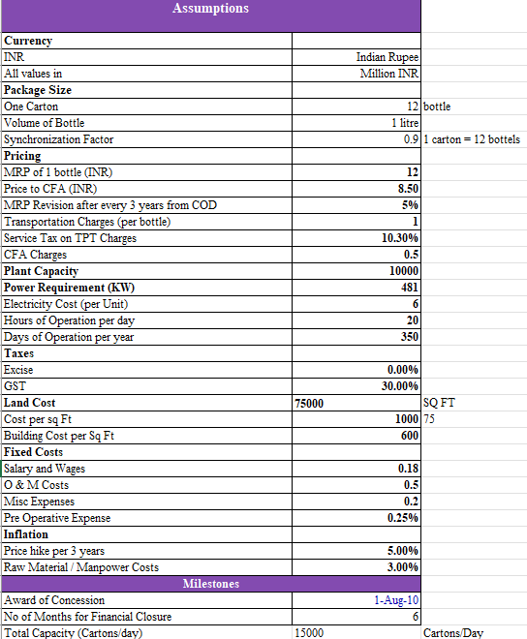

This project assumes a packaged water plant producing 15,000 cartons/day, with key costs defined for land, building, manpower, and operations. Pricing, tax, power, and inflation factors are considered to estimate financial viability and performance.

Financial Data

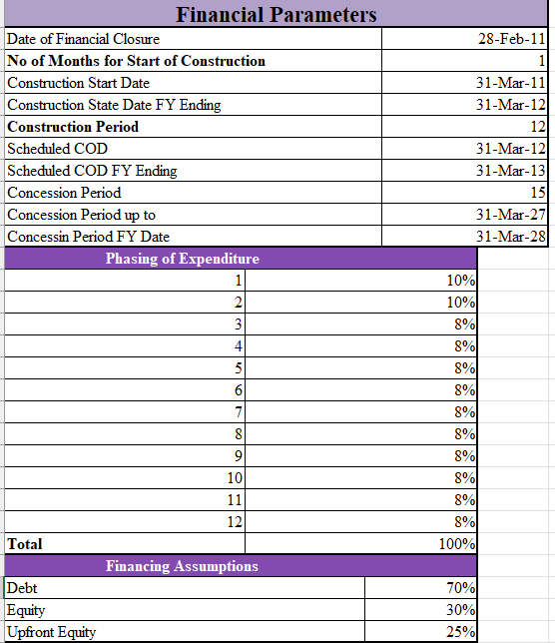

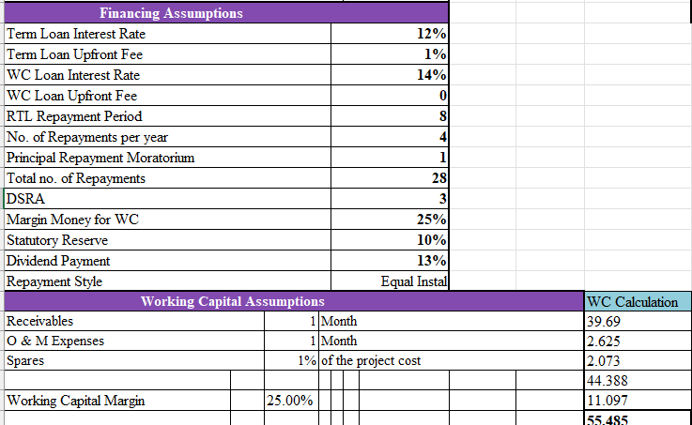

Amortization Schedule Calculation

Without Moratorium
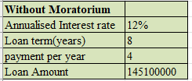
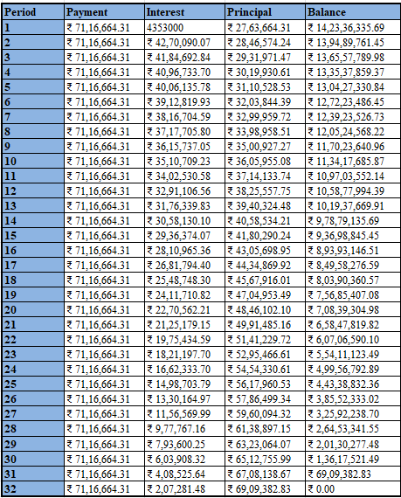

With Moratorium
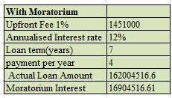
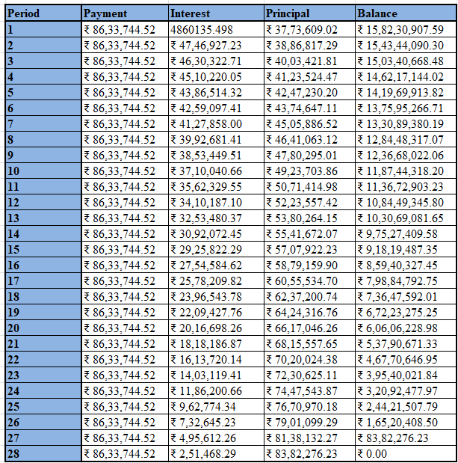
This table shows a declining trend in term loan interest and principal from 2013 to 2019, indicating repayment completion by 2018. Meanwhile, the working capital (WC) loan and interest steadily increase year-on-year, reflecting growing operational needs and business expansion.
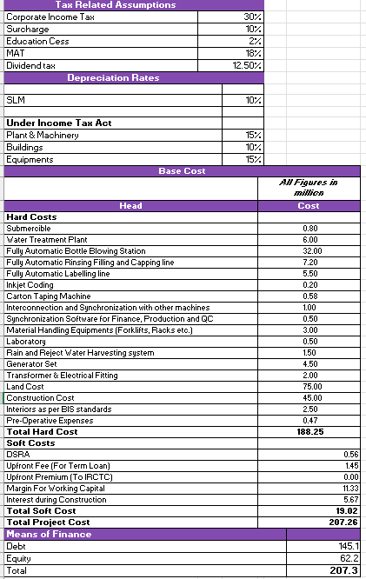
Depreciation
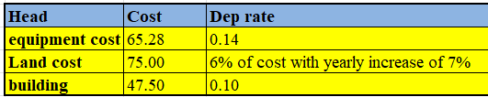
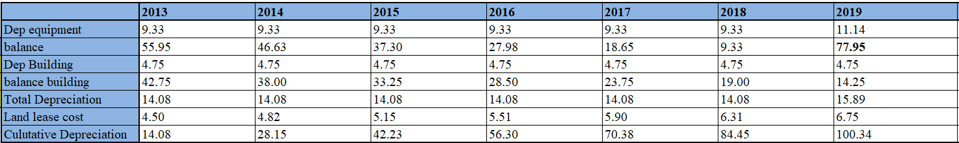
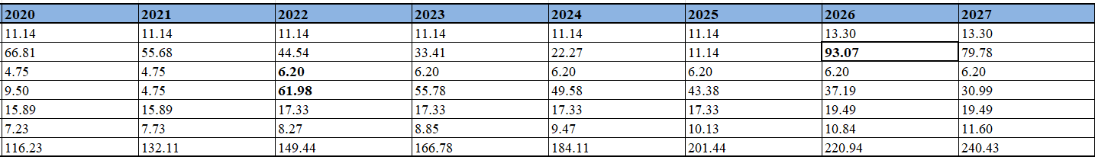

Costing of bottle
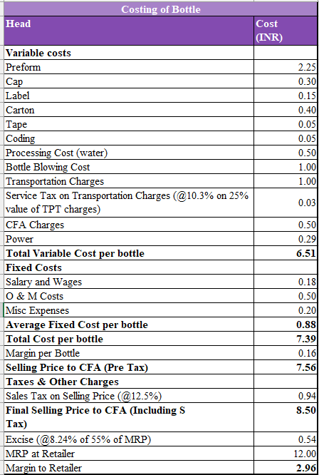

Financial Statements
Profit and loss Statement
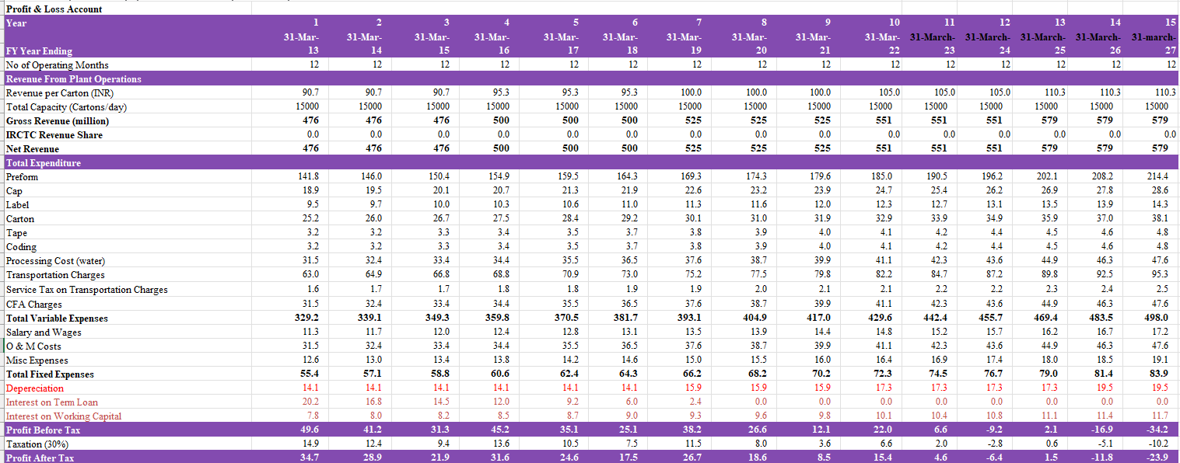
Revenue is growing at 5% in every 3 years
Cost is growing at 3% in every year
- Revenue per carton increases from ₹90.7 to ₹110.3 over 15 years, showing steady growth.
- Gross revenue rises from ₹476 million to ₹579 million with constant production capacity.
- Operating at full capacity of 15,000 cartons/day throughout all years.
- Variable and fixed costs increase year-on-year due to inflation and expansion.
- Major expenses include preform, carton, salaries, and O&M costs.
- Term loan interest reduces to zero by Year 7, reflecting loan repayment.
- Working capital loan and its interest increase consistently, indicating growing working needs.
- Profit before tax peaks early and declines steadily over the years.
- Losses begin from Year 12 onwards, reflecting rising costs and stagnant revenue.
- Taxes are paid only during profitable years; no taxes from Year 12 due to losses.
- Net profit turns negative in the later years, showing unsustainable cost structure.
- Project requires price increase, cost control, or operational efficiency for long-term viability.

Balance sheet
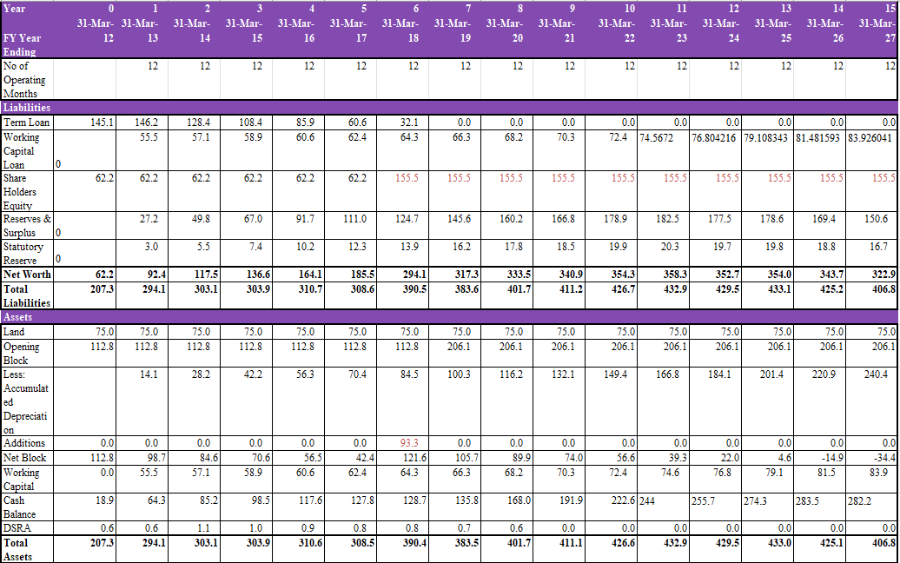
Analysis
- Term loan is fully repaid by Year 7, reducing debt burden.
- Working capital loan rises annually, showing increased operational needs.
- Shareholder equity jumps from Year 5 and stays stable.
- Reserves grow till Year 11, then decline due to losses.
- Net worth peaks in Year 11, then gradually falls.
- Depreciation increases yearly, reflecting asset wear.
- Major asset addition happens in Year 6.
- Cash balance grows till Year 13, then dips.
- Total assets and liabilities remain balanced.

Cash Flow Statement
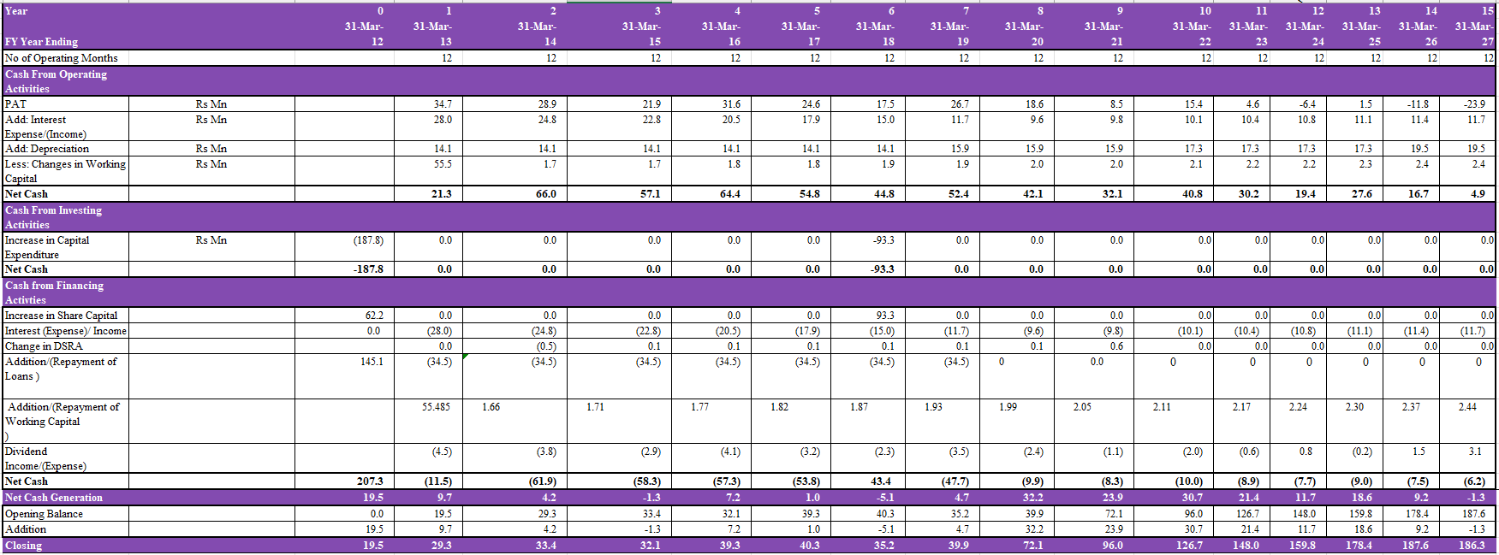
Analysis
- Positive operating cash flow in all years, though declining after Year 6, indicating reduced profitability or efficiency.
- Major capital expenditure occurred in Years 0 and 6, suggesting initial setup and later expansion.
- Cash from financing is high in Year 0 due to equity and loan inflow; turns negative later due to repayments.
- Interest expense declines over time, reflecting reduced debt.
- Depreciation remains stable, with a rise from Year 6 onward indicating asset additions.
- Dividends are paid regularly, showing shareholder returns.
- Closing cash consistently increases till Year 14, showing good liquidity buildup.
- Net cash generation becomes negative in later years, pointing to cash strain or reinvestments.

Outcome
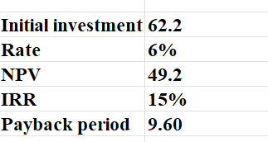

Category-Level Analysis of IRCTC Rail Neer Operations FY 2023-24

1. Introduction
The Indian Railway Catering and Tourism Corporation (IRCTC) operates Rail Neer, a branded packaged drinking water service, across 19 plants categorized as Company Owned, PPP-CS (Public-Private Partnership with Capital Support), and PPP-WCS (Public-Private Partnership without Capital Support). In FY 2023-24, Rail Neer contributed 327 crore to IRCTCs total revenue of 4,270.18 crore, producing 394.94 million bottles. This report provides a category-level analysis of financial performance, including Profit & Loss (P&L), financial ratios, and per-unit economics metrics. All financial values are in crores, and tables are presented horizontally with a smaller font size for clarity. Key metrics, such as Gross Profit Margin, Operating Profit Margin, Net Profit Margin, Expense-to-Revenue Ratio, and Profit Before Tax per Bottle, are analyzed to assess efficiency and profitability, with their significance explained.

2. Production Overview
IRCTCs 19 plants have a total installed capacity of 535.67 million bottles annually, producing 394.94 million bottles in FY 2023-24 (73.73% utilization). Company Owned plants (e.g., Nangloi, Danapur) produced 187.53 million bottles, PPP-CS plants (e.g., Sankrail, Sanand) produced 156.73 million, and PPP-WCS plants (e.g., Amethi, Nagpur) produced 48.76 million. High performers like Nangloi (101.72%) and Sankrail (103.62%) contrast with underperformers like Parassala (29.07%) and Simhadri (22.15%).

3. Plant-Wise Financial Performance (P&L)
The P&L data aggregates financial performance for 12 plants, with total revenue of 286.06 crore, contributing to Rail Neers 327 crore revenue. Missing data for Bilaspur, Maneri, Kota, Bhubaneswar, Bhusawal, Parassala, and Simhadri accounts for the gap. Values are converted from rupees to crores (1 crore = 10,000,000 rupees).

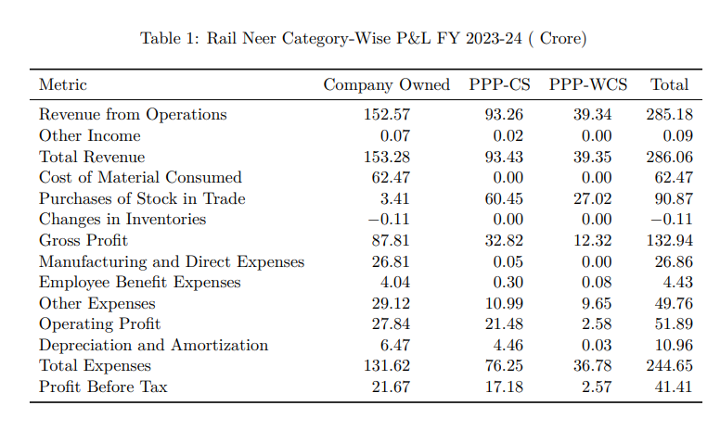
Analysis and Insights
- Revenue Contribution: Company Owned plants contribute 53.6% (153.28 crore), PPPCS 32.7% (93.43 crore), and PPP-WCS 13.7% (39.35 crore). Company Owned plants lead due to high production volumes (187.53 million bottles).
- Cost Structure: Company Owned plants incur high material costs (62.47 crore) and manufacturing expenses (26.81 crore) due to in-house production. PPP-CS and PPPWCS rely on stock purchases (60.45 crore and 27.02 crore), with minimal manufacturing costs
- Profitability: Company Owned plants lead in Profit Before Tax (PBT, 21.67 crore, 52.3% of total), followed by PPP-CS (17.18 crore, 41.5%) and PPP-WCS (2.57 crore, 6.2%). PBT measures earnings before taxes, reflecting operational profitability.
- Significance of PBT: High PBT in Company Owned plants indicates efficient scale, while PPP-WCSs low PBT suggests cost challenges, necessitating expense optimization.

4. Financial Ratios
Financial ratios assess efficiency and profitability across categories. Gross Profit Margin (Gross Profit/Total Revenue) measures revenue retention after material costs. Operating Profit Margin (Operating Profit/Total Revenue) reflects profitability after operating expenses. Net Profit Margin (Profit Before Tax/Total Revenue) shows overall profitability. Expense-to-Revenue Ratio (Total Expenses/Total Revenue) indicates cost efficiency. Return on Revenue mirrors Net Profit Margin, assessing revenue efficiency.

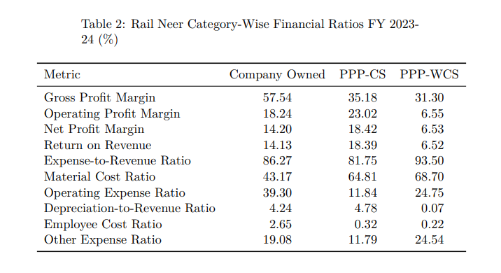
Analysis and Insights
- Profitability: PPP-CS leads in Operating Profit Margin (23.02%) and Net Profit Margin (18.42%) due to low operating expenses (11.84% Operating Expense Ratio). Company Owned follows (14.20% Net Profit Margin), while PPP-WCS lags (6.53%) due to high expenses.
- Efficiency: PPP-CS has the lowest Expense-to-Revenue Ratio (81.75%), reflecting cost efficiency. PPP-WCSs high ratio (93.50%) indicates cost optimization needs, driven by other expenses (24.54%).
- Material Costs: PPP-WCS (68.70%) and PPP-CS (64.81%) have high Material Cost Ratios due to stock purchases, while Company Owned (43.17%) benefits from in-house production.
- Significance of Metrics: High Gross Profit Margin in Company Owned plants (57.54%) indicates production efficiency. PPP-CSs high Operating Profit Margin reflects lean operations, while PPP-WCSs low margins highlight cost inefficiencies.

5. Unit Economics Metrics
Per-unit economics provide insights into per-bottle profitability. Profit Before Tax per Bottle measures earnings per unit sold, guiding pricing and cost strategies.
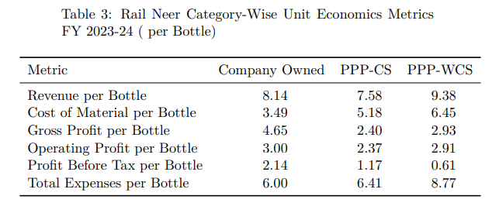
Analysis and Insights
- Revenue per Bottle: PPP-WCS leads (9.38), followed by Company Owned (8.14) and PPP-CS (7.58). All are below the standard 15 price, suggesting discounts or regional pricing variations.
- Profitability: Company Owned has the highest Profit Before Tax per Bottle (2.14), followed by PPP-CS (1.17) and PPP-WCS (0.61). High material costs in PPP-WCS (6.45) reduce profitability.
- Cost Efficiency: Company Owned has the lowest Total Expenses per Bottle (6.00), while PPP-WCSs high expenses (8.77) impact margins.
- Significance of Profit Before Tax per Bottle: This metric highlights per-unit profitability. Company Owneds high value reflects efficient scale, while PPP-WCSs low value suggests pricing or cost adjustments are needed.

6. Strategic Recommendations
- Optimize PPP-WCS Operations: Address high Expense-to-Revenue Ratio (93.50%) and material costs (6.45 per bottle) through cost reduction in other expenses (24.54%) and operational audits in low-utilization plants (e.g., Parassala: 29.07%).
- Scale PPP-CS Model: Expand PPP-CS plants, given their high Net Profit Margin (18.42%) and low Operating Expense Ratio (11.84%). Increase capacity at plants like Sankrail (103.62% utilization).
- Leverage Company Owned Strengths: Utilize high Gross Profit Margin (57.54%) and production volumes by optimizing manufacturing costs (26.81 crore) and expanding high performers like Nangloi (101.72% utilization).
- Standardize Pricing: Increase Revenue per Bottle to approach 15 to boost revenue by 3050%, especially for PPP-CS and PPP-WCS plants.
Conclusion
In FY 2023-24, Company Owned plants led in revenue (153.28 crore) and Gross Profit Margin (57.54%), driven by high production volumes. PPP-CS plants excelled in profitability (18.42% Net Profit Margin) due to lean operations, while PPP-WCS lagged (6.53% Net Profit Margin) due to high expenses. By optimizing costs in PPP-WCS, scaling PPP-CS, and leveraging Company Owned plants scale, IRCTC can enhance Rail Neers financial performance and operational efficiency.

Comprehensive Report on IRCTC Rail Neer Operations FY 2023-24

1. Introduction
The Indian Railway Catering and Tourism Corporation (IRCTC), a Mini Ratna (Category-I) and Navratna-status public sector undertaking under the Ministry of Railways, Government of India, operates Rail Neer, a branded packaged drinking water service. Launched in 2003, Rail Neer ensures safe, clean drinking water for Indian Railways passengers, adhering to Bureau of Indian Standards (BIS) IS 14543. In FY 2023-24, Rail Neer contributed ff327 crore to IRCTC’s total revenue of ff4,270.18 crore (7.65%), producing over 395 million bottles across 19 plants. This report consolidates plant-wise production, financial performance (with P&L values in crores), financial ratios, unit economics, and plant details for FY 2023-24, with all tables presented horizontally on separate pages using a slightly smaller font size to ensure no data is missed. It provides insights into operational efficiency, profitability, and strategic opportunities.

2. Plant-Wise Production and Capacity (FY 2023-24)
IRCTC operates 19 Rail Neer plants, with a total installed capacity of 535.67 million bottles annually, producing 394.94 million bottles and despatching 390.89 million bottles in FY 2023-24, achieving 73.73% capacity utilization. The plants are categorized as Company Owned, PPP-CS (Public-Private Partnership with Capital Support), and PPP-WCS (Public-Private Partnership without Capital Support).

Plant Details
The following table summarizes plant establishment and production capacity.

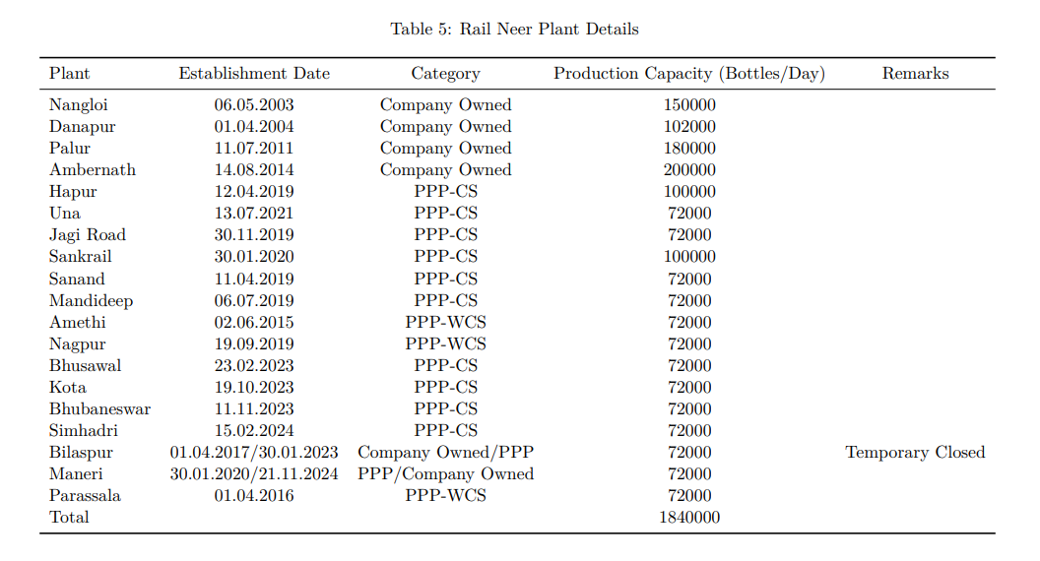

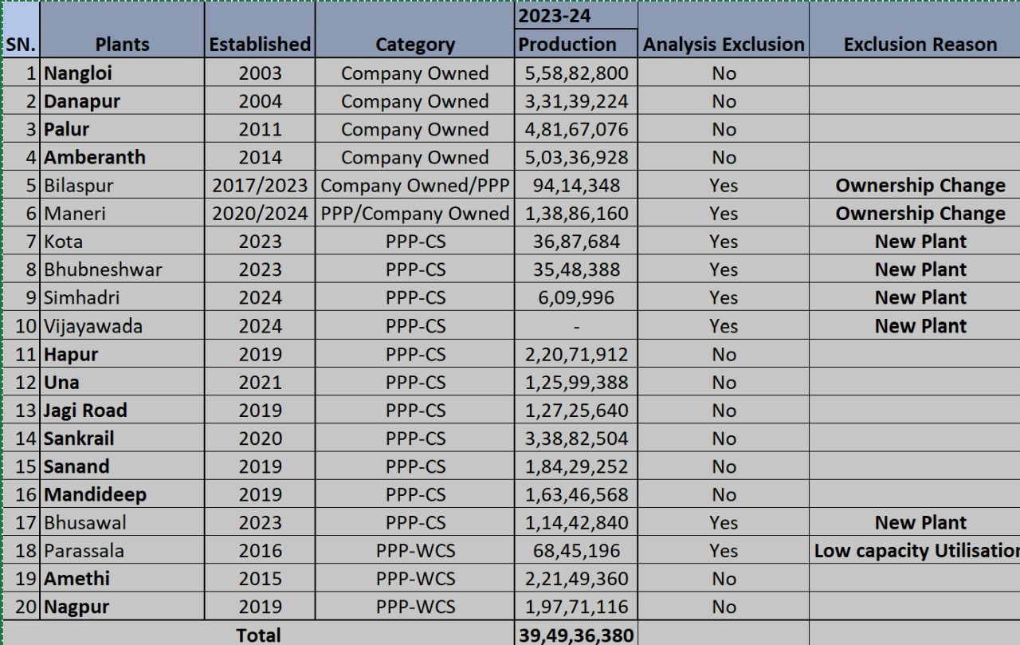

Analysis and Insights
- Plant Age and Efficiency: Older plants (e.g., Nangloi, Danapur, est. 2003-2004) have higher capacities (150,000–200,000 bottles/day) and utilization (e.g., Nangloi: 101.72%), while newer plants (e.g., Simhadri, est. 2024) have lower output due to partial-year operations.
- PPP Model: PPP-CS plants (e.g., Sankrail, Hapur) benefit from capital support, showing competitive profitability (e.g., Sankrail: 25.78% Net Profit Margin). PPP-WCS plants (e.g., Amethi, Nagpur) have lower margins due to higher expenses.
- Temporary Closures: Bilaspur’s temporary closure explains its low production (9.41 million bottles), impacting overall capacity utilization.

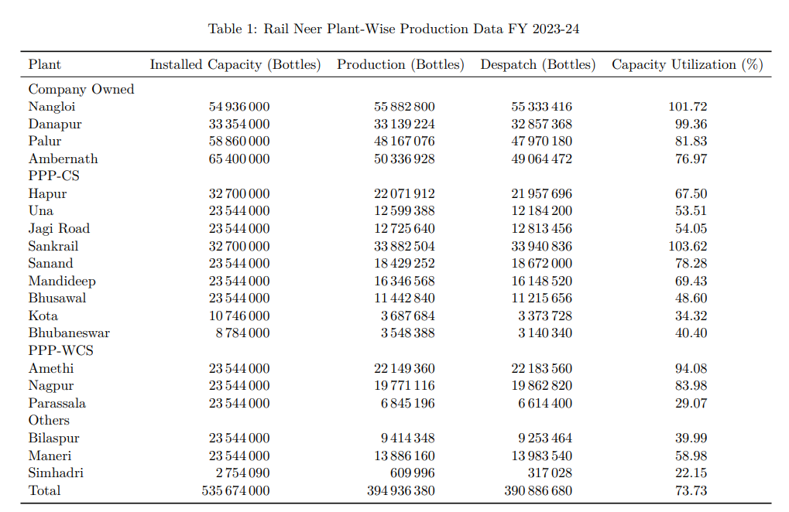
Analysis and Insights
- High Performers: Nangloi (101.72%) and Sankrail (103.62%) exceeded installed capacity, indicating operational efficiencies or potential data adjustments. Danapur (99.36%) and Amethi (94.08%) also achieved high utilization, reflecting strong demand in their regions (Delhi, Bihar, Uttar Pradesh).
- Underperformers: Newer plants like Kota (34.32%), Bhubaneswar (40.40%), Bhusawal (48.60%), and Simhadri (22.15%) show low utilization, likely due to partial-year operations (e.g., Simhadri started February 2024). Parassala’s 29.07% utilization suggests operational challenges in Kerala.
- Production vs. Despatch: The 4.05 million bottle gap (394.94M produced vs. 390.89M despatched) indicates minor inventory accumulation or losses, particularly at Ambernath (1.27M bottle difference).
- Strategic Implications: Low-capacity plants (e.g., Parassala, Bhusawal) require operational audits or demand stimulation. Expanding high-performing plants like Nangloi and Sankrail could boost overall output to meet growing demand.

3. Plant-Wise Financial Performance (P&L)
The P&L data covers 12 plants, with total revenue of ff246.07 crore, contributing to Rail Neer’s reported ff327 crore revenue, indicating partial coverage (excluding Bilaspur, Maneri, Kota, Bhubaneswar, Simhadri, Bhusawal, Parassala). All values are presented in crores for clarity

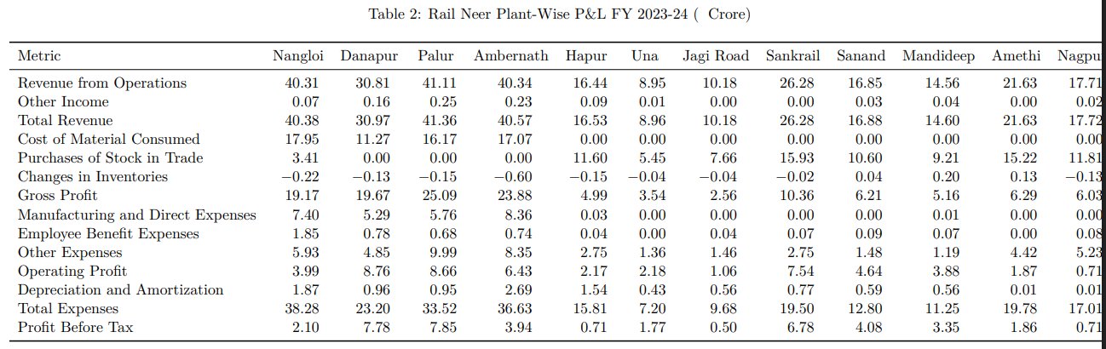

Analysis and Insights
- Revenue Contribution: The 12 plants generated 246.07 crore in total revenue, with Company Owned plants contributing 62% (152.78 crore), PPP-CS 38% (93.42 crore), and PPP-WCS 16% (39.35 crore). Palur (41.36 crore) and Nangloi (40.38 crore) led in revenue, while Una (8.96 crore) and Jagi Road (10.18 crore) were the lowest.
- Cost Structure: Company Owned plants incur higher material costs (e.g., Nangloi: 17.95 crore), while PPP plants rely on stock purchases (e.g., Sankrail: 15.93 crore), reflecting different operational models. PPP-WCS plants like Amethi have high other expenses (4.42 crore), impacting profitability.
- Profitability: Danapur (7.78 crore) and Palur (7.85 crore) show the highest Profit Before Tax, driven by high gross profits and lower expense ratios. Jagi Road (0.50 crore) and Hapur (0.71 crore) have the lowest profits, indicating cost inefficiencies.
- Expense Drivers: Manufacturing and direct expenses are significant for Company Owned plants (e.g., Ambernath: 8.36 crore), while PPP plants have minimal direct expenses, relying on stock purchases. Other expenses are high for Palur (9.99 crore) and Nagpur (5.23 crore), suggesting potential for cost optimization.

4. Financial Ratios
Financial ratios provide insights into efficiency and profitability across plants.

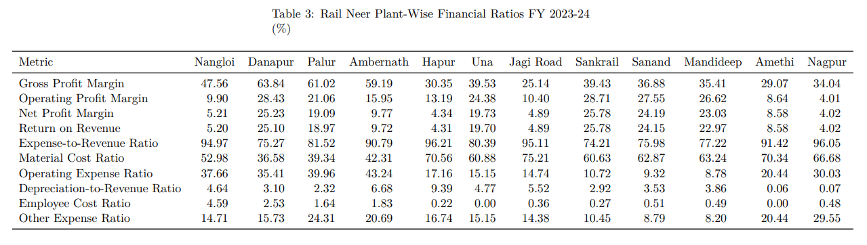Analysis and Insights
- Profitability: Danapur (25.23% Net Profit Margin) and Sankrail (25.78%) are the most profitable, driven by high Operating Profit Margins (28.43% and 28.71%). Jagi Road (4.89%) and Hapur (4.34%) have the lowest margins, indicating cost inefficiencies.
- Efficiency: Sankrail (74.21%) and Danapur (75.27%) have the lowest Expense-to-Revenue Ratios, reflecting cost efficiency. Hapur (96.21%) and Nagpur (96.05%) have high ratios, suggesting cost optimization needs.
- Material Costs: PPP plants (e.g., Jagi Road: 75.21%, Hapur: 70.56%) have higher Material Cost Ratios due to reliance on stock purchases, while Company Owned plants (e.g., Danapur: 36.58%) benefit from in-house production.
- Operating Expenses: Company Owned plants have higher Operating Expense Ratios (e.g., Ambernath: 43.24%) due to manufacturing costs, while PPP-CS plants (e.g., Sanand: 9.32%) are leaner.
- Depreciation Impact: Ambernath (6.68%) and Hapur (9.39%) have high Depreciation-toRevenue Ratios, indicating capital-intensive operations.

5. Unit Economics Metrics
Unit economics metrics provide per-bottle financial insights, based on production volumes.

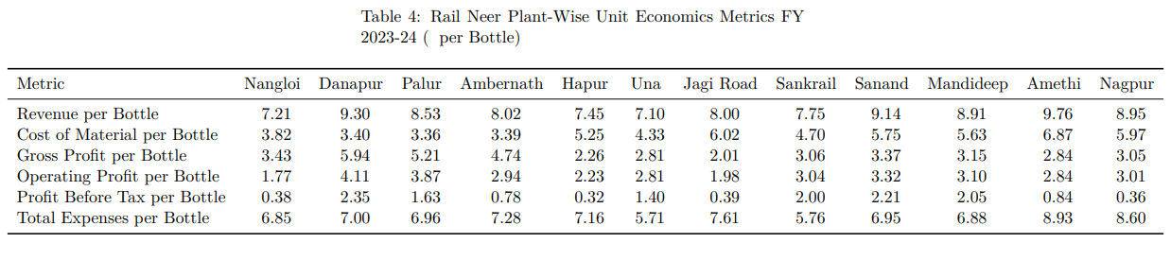
Analysis and Insights
- Revenue per Bottle: Amethi (9.76) and Danapur (9.30) have the highest Revenue per Bottle, but the standard price of 15 suggests discounts or cost adjustments. Una (7.10) and Hapur (7.45) have lower revenues, possibly due to regional pricing or lower sales volumes.
- Cost Efficiency: Una (5.71) and Sankrail (5.76) have the lowest Total Expenses per Bottle, driving higher Profit Before Tax per Bottle (1.40 and 2.00). Amethi (8.93) and Nagpur (8.60) have high expenses, impacting profitability.
- Profitability: Danapur (2.35) and Sanand (2.21) show the highest Profit Before Tax per Bottle, while Hapur (0.32) and Nagpur (0.36) are the lowest, reflecting high material costs (e.g., Amethi: 6.87).
- Material Costs: PPP plants (e.g., Jagi Road: 6.02, Amethi: 6.87) have higher Cost of Material per Bottle due to stock purchases, while Company Owned plants (e.g., Palur: 3.36) benefit from in-house production.

6. Strategic Recommendations
- Optimize Underperforming Plants: Parassala (29.07% utilization), Kota (34.32%), and Bhusawal (48.60%) require operational audits to address low capacity utilization. Strategies include demand stimulation or process improvements
- Cost Optimization: High Other Expense Ratios in Palur (24.31%) and Nagpur (29.55%) suggest potential for cost reduction in administrative or overhead expenses.
- Leverage High Performers: Expand capacity at Nangloi and Sankrail, which exceed 100% utilization, to meet growing demand and boost revenue
- Pricing Strategy: Revenue per Bottle (7.10–9.76) is below the standard 15 price, indicating discounts or inefficiencies. Standardizing pricing could increase revenue by 30–50%.
- Expand PPP Model: The profitability of PPP-CS plants (e.g., Sankrail, Sanand) suggests scaling this model for new plants to balance capital investment and operational efficiency.

Conclusion
In FY 2023-24, Rail Neer produced 394.94 million bottles, generating 327 crore in revenue, driven by efficient Company Owned plants (e.g., Danapur, Palur) and select PPP-CS plants (e.g., Sankrail, Sanand). While older plants demonstrate high utilization and profitability, newer plants and those with operational challenges (e.g., Parassala, Bilaspur) require attention. By optimizing costs, standardizing pricing, and leveraging high-performing plants, IRCTC can enhance Rail Neer’s contribution to its revenue and strengthen its position as a key player in packaged drinking water for Indian Railways.

FINAL CONCLUSION

The financial analysis of IRCTC’s Rail Neer operations underscores the strategic importance and growth potential of the packaged drinking water segment within the Indian Railways ecosystem. The study reveals that while existing plants are operating at an average capacity utilization of 73.73%, there is significant variation in performance across different operational models. Company Owned and PPP-CS plants demonstrate better profitability and efficiency, whereas PPP-WCS models face challenges due to high costs and lower margins. Financial projections for a new plant indicate early profitability but highlight the need for continuous cost control, operational efficiency, and periodic price adjustments to ensure long-term sustainability. Given the directive from the Railway Board and comparative analysis of implementation models, the PPP model with capital support emerges as the most viable strategy for future expansion. With appropriate risk mitigation, pricing reforms, and strategic site selection, IRCTC can strengthen Rail Neer’s position as a reliable, cost-effective, and sustainable source of packaged drinking water for railway passengers across India.

